Regional warhouse logistics coordinator ( Logistics update to despatch update )

Parts coordinator done the SO DO update ,

System assigned the issue ticket to the regional warehouse logistics coordinator

Logistics coordinator do the login

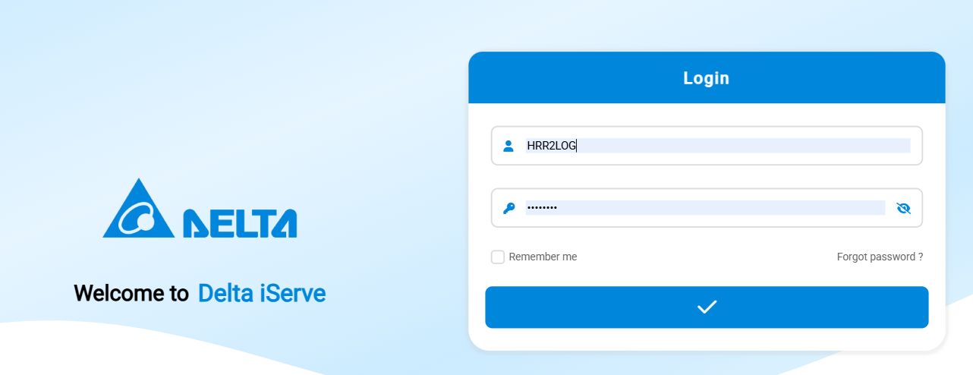.

Go to inventory issue module and see the assigned issue ticket

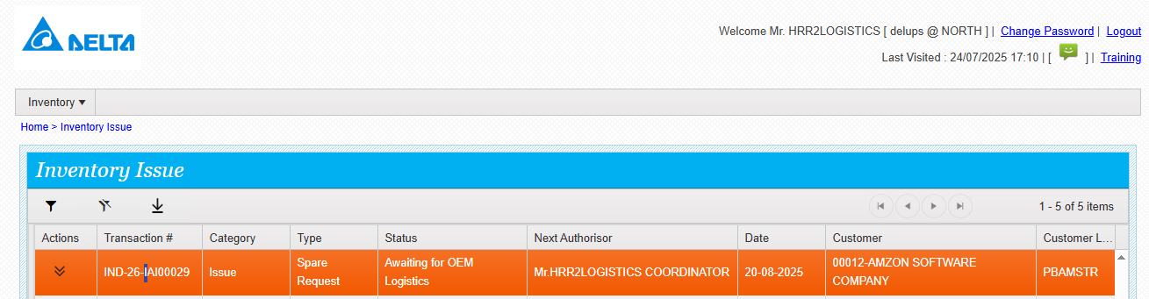

Go to action button and click on logistics update

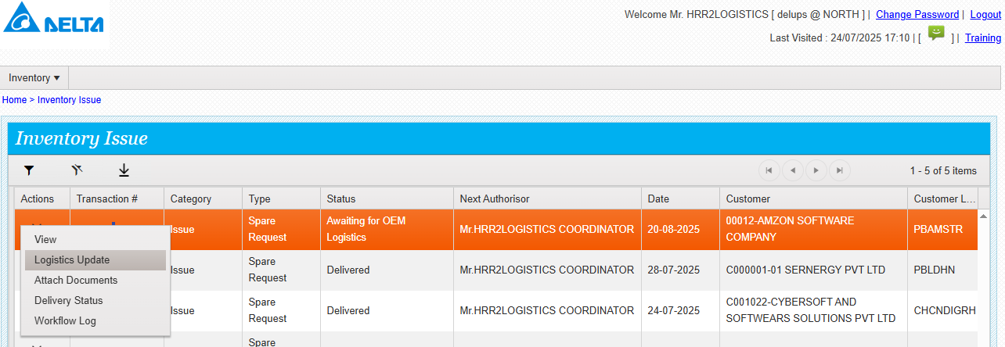

Update the required details and submit

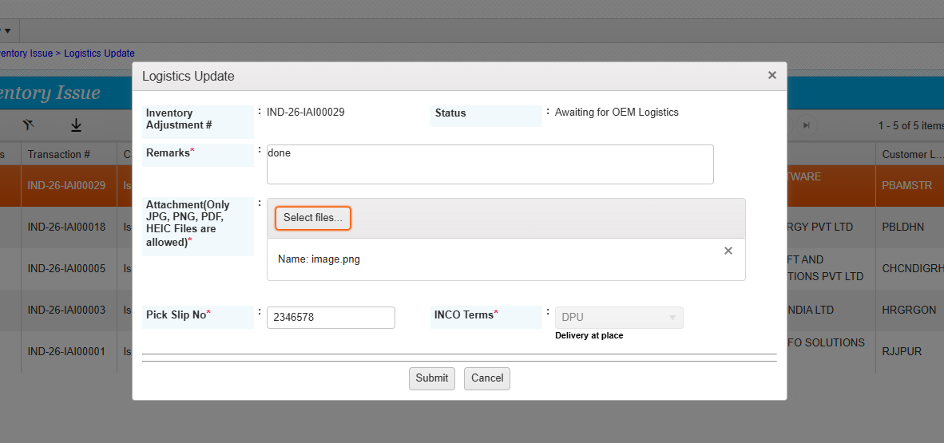

Logistics update done successfully

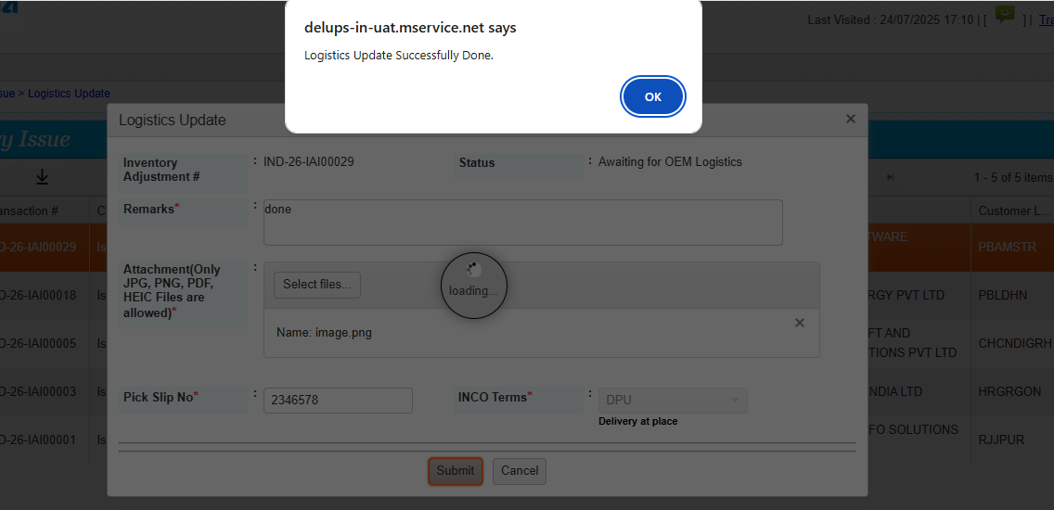

Before proceeding pick pack update do the stock update in regional warehouse.

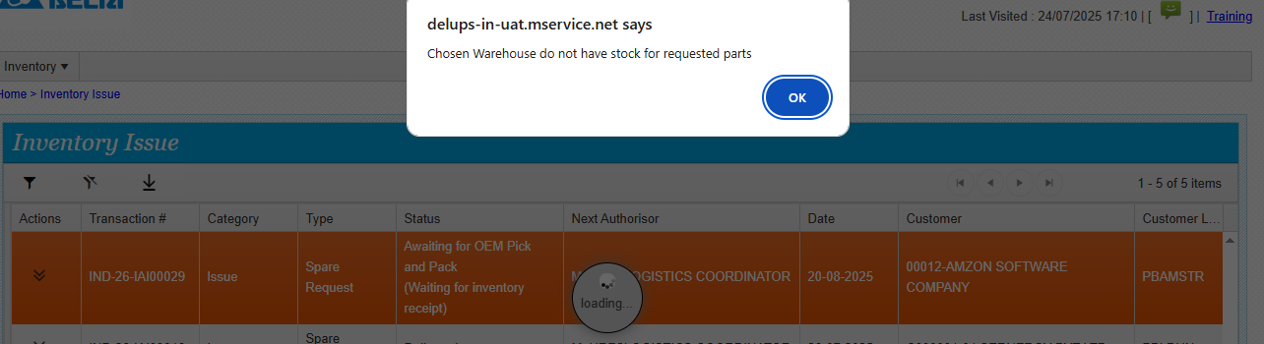

System geenrate one receipt and keep it ready for the grn

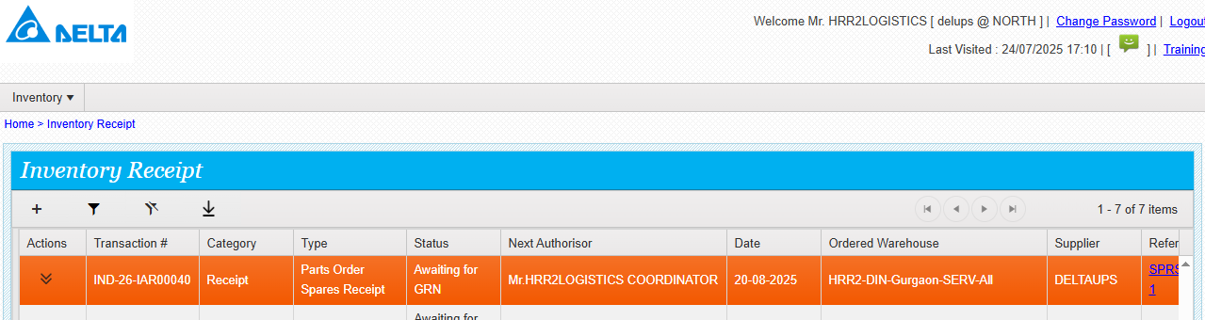

Click on action and do the GRN/ IF it is a serialised item required to edit the receipt and udpate the serial nos .or else the system throw a notification as below

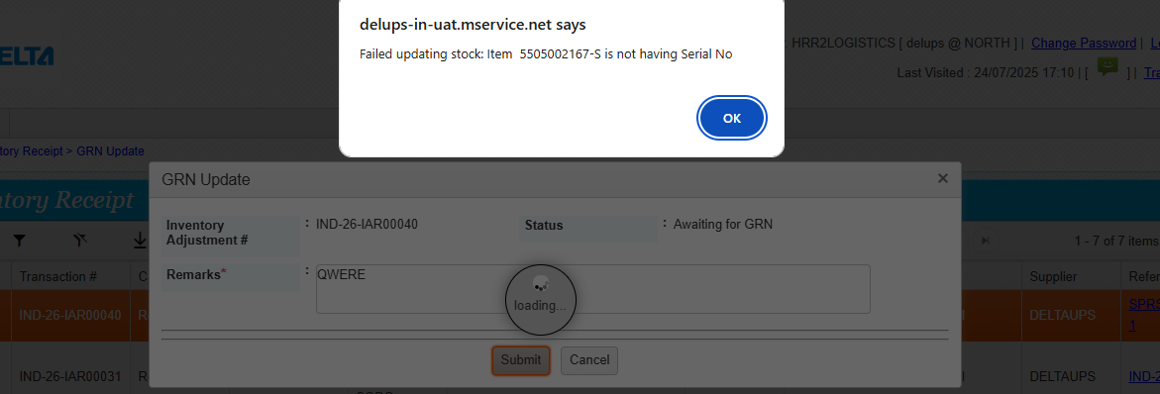

Click on edit and update the serial no

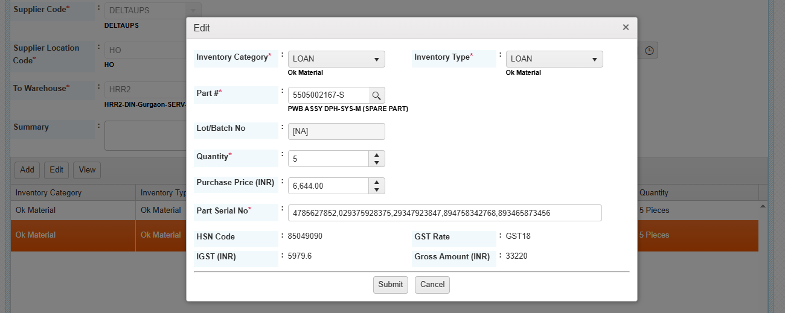

Now do the GRN

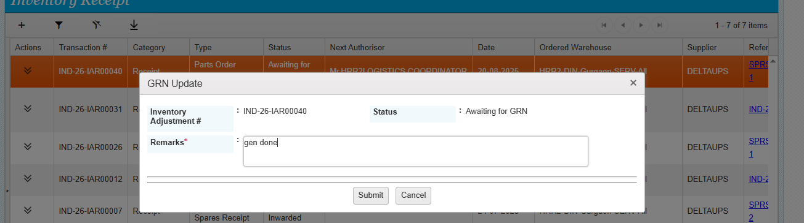

Grn done successfully.

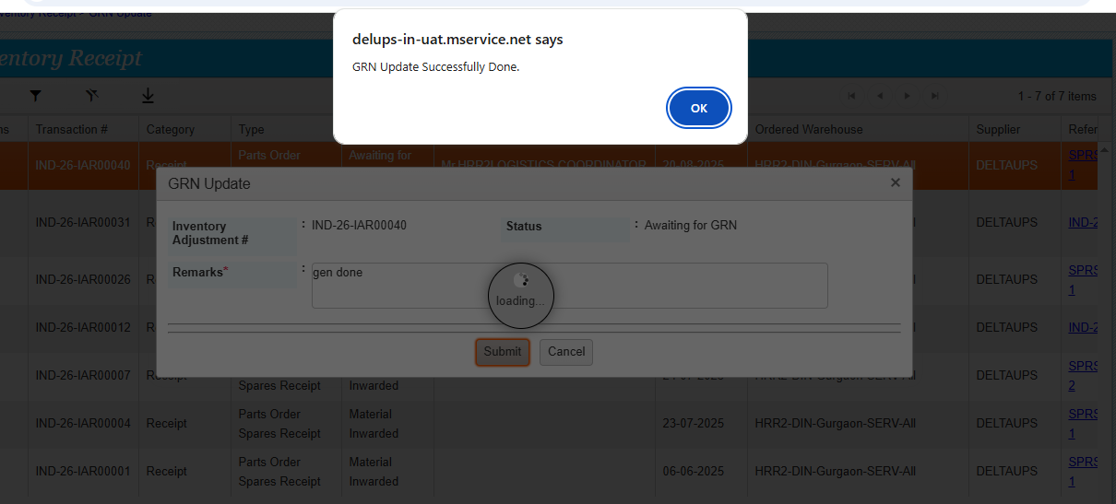

Now go to inventory issue module and do the pick pack update

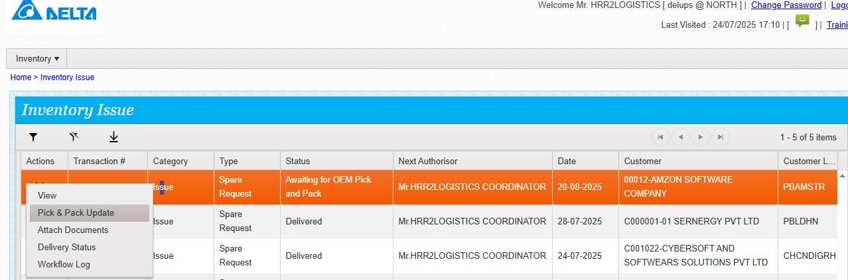

Click the pick pack action and see the below screen and update the details , select the serial nos for the serialised items

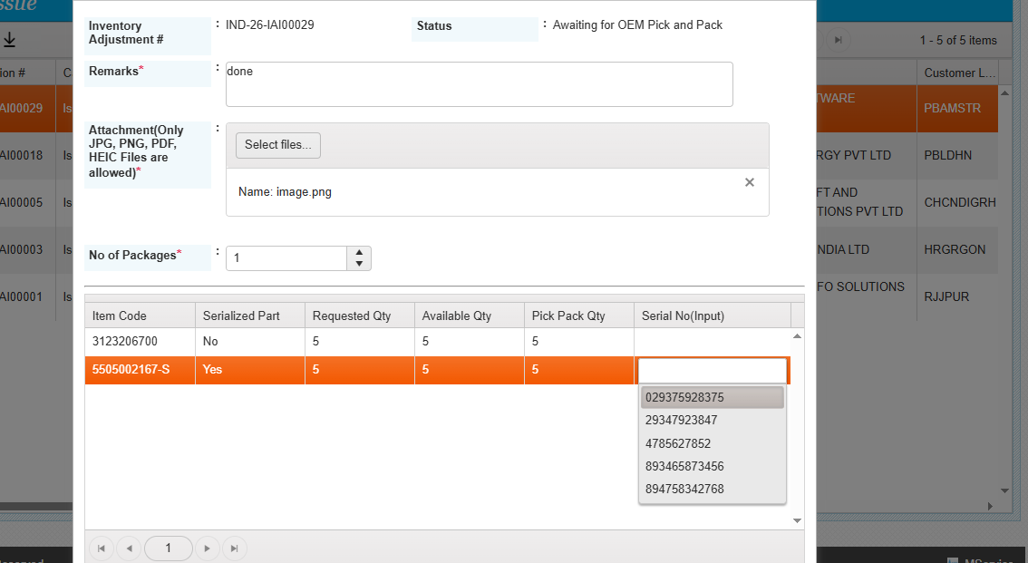

Pick pack done successfully

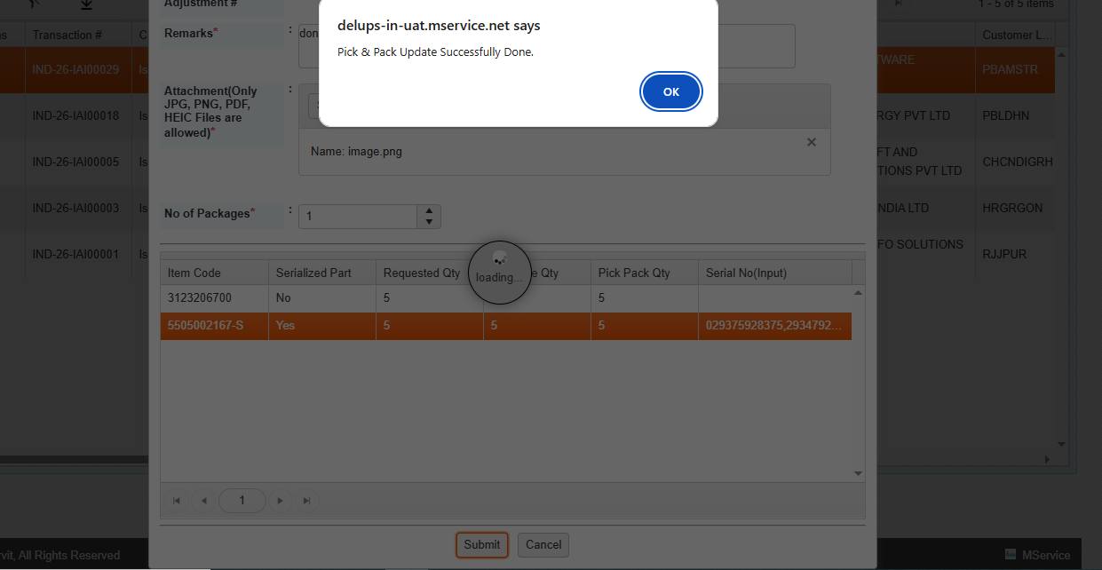

Now the status is awaiting for OEM despatch

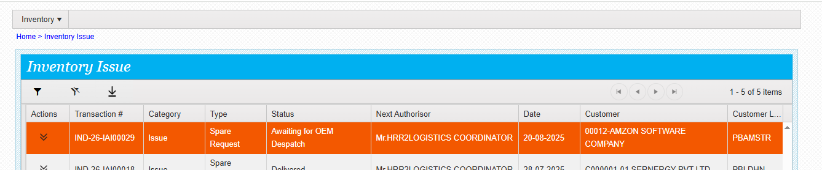

Go to action and click on despatch update and fill the required detals,

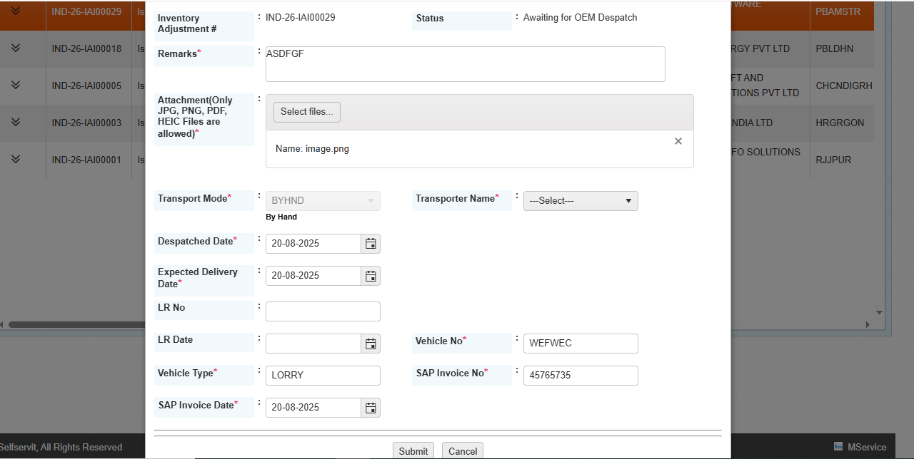

Despatch update done successfully

